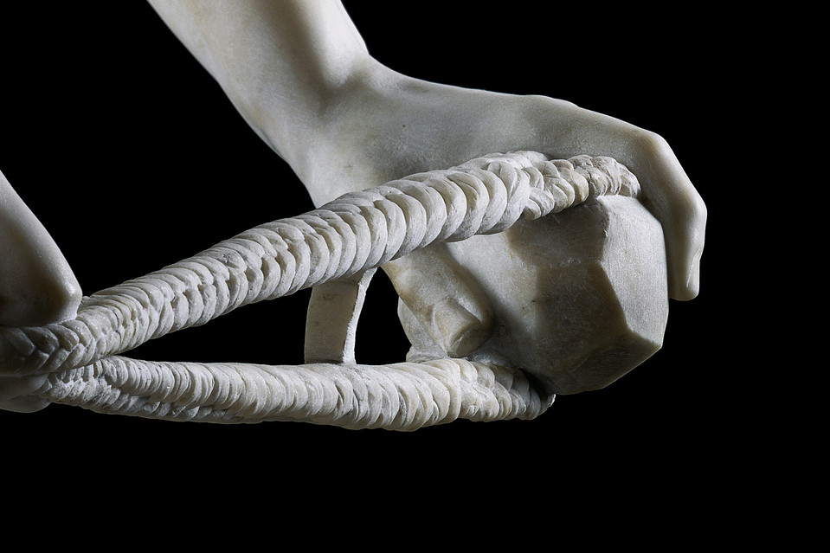
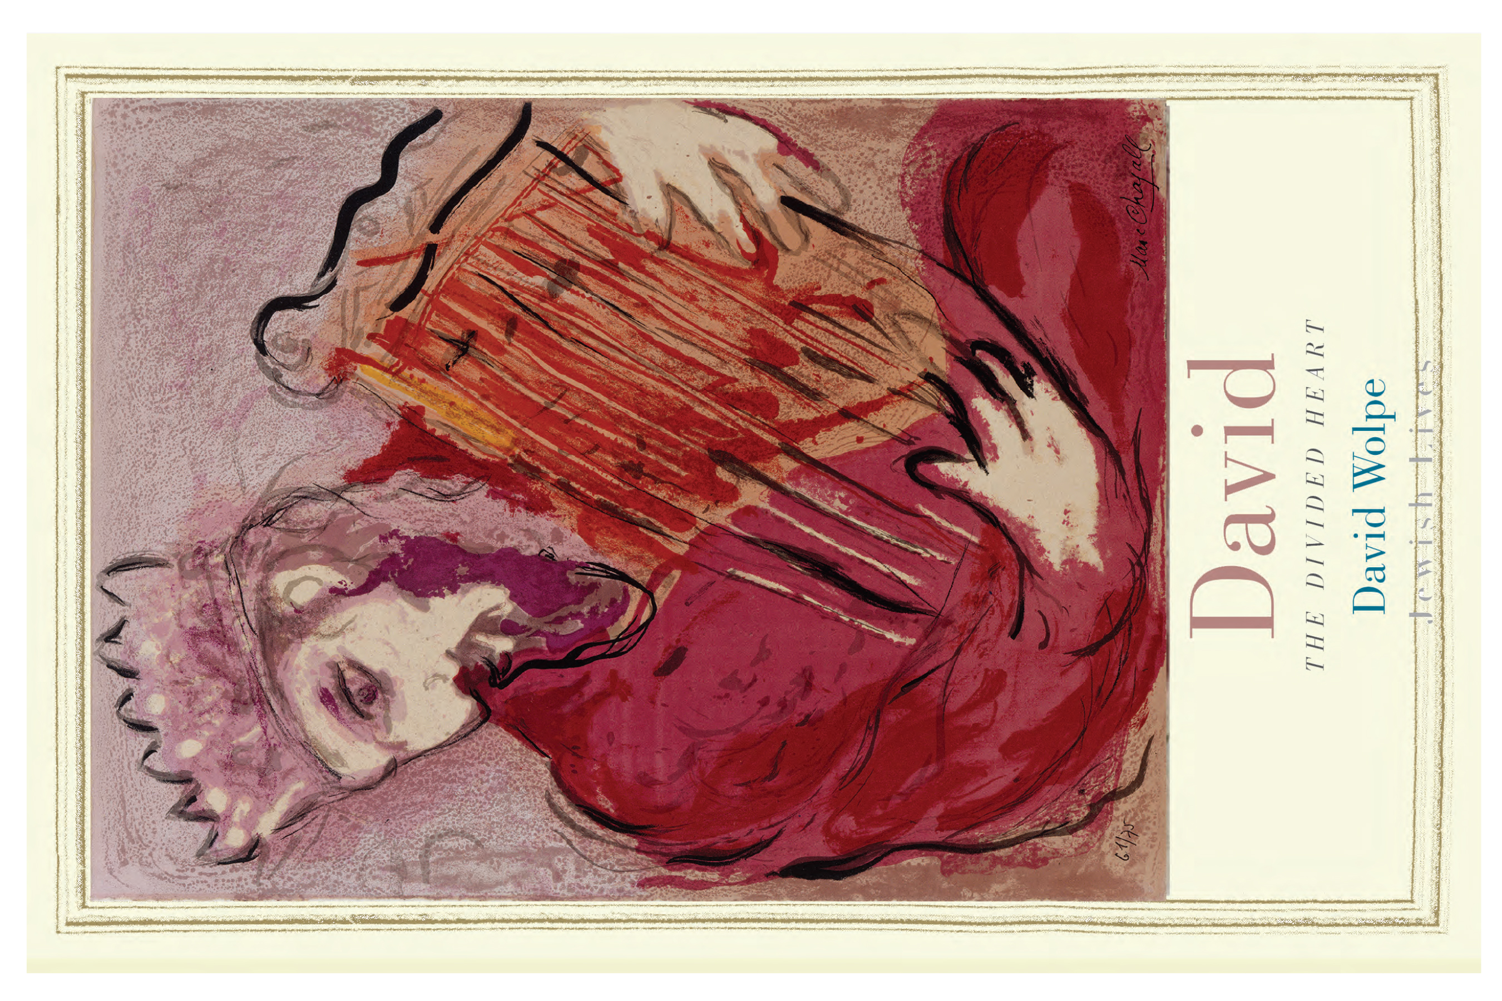
BOOKSHELF – Wall Street Journal Review
The Shepherd Who Would Be King
David’s connection to God often seems more stable and sure than his relationships to other human beings.
A review of ‘David,’ by David Wolpe.

By ALLAN MASSIE
Oct. 31, 2014 4:46 p.m. ET

The ‘attractively flawed’ David is, according to Rabbi David Wolpe, “the first person in history whose tale is complete and vital, laced with passions, savagery, hesitation, betrayal, charisma, faith, family—the rich canvas of a large life.“ Some might reply: What about Odysseus? Certainly his tale is equally “complete and vital,” and it is likely that the stories of his journeys from Troy to Ithaca had been written down before the Jewish scribes of the Babylonian Exile produced the Books of Samuel and the first book of Chronicles. True, there is no proof that Odysseus ever existed outside Homer—but Rabbi Wolpe admits that “there was once a considerable debate over whether David indeed existed“ and “it remains an uncomfortable fact that nothing unequivocal has been found that can be traced to his hand or identified with his rule.”
Like Achilles and Hector, Odysseus and Agamemnon, David is part of our cultural history. Everyone knows about David and Goliath, David and Jonathan, David and Bathsheba, David and the rebellion led by his son Absalom. He has been the subject of statues, paintings, poems, novels and plays. Despite the dearth of archaeological evidence, but there is a wealth of commentary from biblical scholars, both Jewish and Christian, on which Rabbi Wolpe has drawn to produce ”David: The Divided Heart.”
DAVID
By David Wolpe
http://www.amazon.com/David-Divided-Heart-Jewish-Lives/dp/0300188781/ref=sr_1_1_twi_2?s=books&ie=UTF8&qid=1414956328&sr=1-1&keywords=David+by+David+Wolpe

David was the chosen of God. The Old Testament writers have no doubt about that. Samuel, the old Judge of Israel, having declared that the Almighty had rejected Israel’s first king, Saul, sought out the young David, called him from the care of his sheep and anointed him. The biblical account has a fairy-tale motif: It is the insignificant, even despised, youngest son who is elected the hero (and who slays a giant). Fair enough; yet part of the fascination lies in the fact that this charismatic figure—poet, musician, soldier, lover, ruler and murderer—is no plaster saint but a man of rich and complicated humanity.

Not everyone approves of him. As Field-Marshal Lord Wavell, one of the last Viceroys of India, once remarked: “I have always had great sympathy for the character of Saul and distaste for that of David. Both committed crimes, but David’s were underhand. Murder even in hot blood is a crime, but murder by proxy is surely mean; and David was responsible for three such murders.” One might remark here that this is one good reason for accepting the biblical account as authentic. Though David is the hero-king, the Chosen of the Lord and the ancestor of the Messiah, his faults, sins and even crimes are not glossed over.

In his time as an outlaw, proscribed by Saul, David allies himself to Israel’s enemies, the Philistines. Rabbi Wolpe observes that “an author with David’s best interests in mind would never tell us of David’s sojourn and his massacres. This is such a distasteful tale in almost all its aspects that we must imagine it was so well known that the author did not think he could omit it.” Perhaps—though there may be more than one author, each with a different point of view, only later brought into a sort of cohesion by scribes.
What of David and Jonathan? Jonathan was Saul’s son and heir, who befriended and protected David, though David would supplant him. His love for David was “wonderful, passing the love of women.” Not surprisingly their “relationship has been the subject of a great deal of speculation and assertion, much of it having more to do with the writer’s agenda than with the biblical story.” Rabbi Wolpe sensibly leaves the question open, though he writes: “If the taboo against homosexuality was as strong as we infer from other biblical texts, then it is hard to believe that the biblical author assumed the relationship would be understood sexually.”
This may well be true, though the same author is not loath to show David guilty of the sins of adultery and murder. Pertinently, however, Rabbi Wolpe notes that David is less often shown as the lover than as the beloved (indeed, that is what the name “David” means). Even in the story of Bathsheba, he is evidently driven by lust, not love. It is the sight of her bathing on a rooftop that enflames him, when he doesn’t yet know who she is. Nothing that follows suggests that he came to feel love for her.
The troubles of David’s last years come from his flaws as a father. He takes no effective action when his favored son, Ammon, rapes his half-sister Tamar; and when her full brother Absalom arranges Ammon’s murder and goes into exile, David reluctantly lets him come home and then ignores him for three years, eventually provoking his rebellion. So David is weak in old age, as so many are, and when he weeps for Absalom after his general Joab kills the young man, Joab’s stern reproof is surely to the point: “Thou has shamed this day the faces of all thy servants, which this day have saved thy life . . . In that thou lovest thine enemies and hatest thy friends.”

Men have fought and died to defeat the rebels who threatened David’s throne, and yet the king has tears only for his son who led the revolt. Joab is right to be angry, and yet it is David’s lament over Absalom that echoes movingly down the centuries: “Would God I had died for thee, Absalom, my son, my son!”
Even as we respond to it, we know that he will have his revenge on Joab for his humiliating speech; in his will he leaves instructions for his son Solomon to have the general liquidated. Joab was a thug, himself guilty of murdering two rivals for the position of David’s commander in chief, and the man who obediently put Bathsheba’s first husband, Uriah, “in the forefront of the battle” so that he might be killed. But one can’t but feel sympathy for him. He did a lot of David’s dirty work, and one suspects that David always disliked him.

For many today God is a stumbling-block. Even devout Christians may find it hard to believe that David was in direct communication with the Almighty. Yet the biblical authors have no such doubt. “David,” Rabbi Wolpe writes, “several times asks questions of God and is answered. God provides David with advice for battle and speaks to him through prophets like Nathan and Gad. . . . At times David’s connection to God seems more stable and sure than his relationship to other human beings.” It’s not unusual for leaders to feel, even believe, that they are the instruments of a divine purpose. Oliver Cromwell certainly did; Abraham Lincoln perhaps also. David’s awareness of the reality and power of God is most evident in his Psalms—assuming, that is, that he wrote those attributed to him. “Repeatedly we find that certain Psalms appear to open a pathway to David’s inner life,” Rabbi Wolpe writes. “Oh Lord, rebuke me not in thy wrath: neither chastise me in thy hot displeasure. For thine arrows stick fast in me, and thy hand presseth me sore.”

This is an excellent study of the most fascinating character in the Old Testament. When Samuel dismissed Saul, he told him that “the Lord has already sought out for Himself a man after his own heart.” “After his own heart,” Rabbi Wolpe repeats. “David in character is like God in action. The inexplicable amalgam of good and evil is filtered through human hearts that embrace the totality of God’s world.” The author is right to say of David that, “in his sinfulness and sublimity, he is the most human of us all.”

